Curriculum Vitae

NAME : RAHUL KUMAR SHAH  EMAIL ID : rahul.shah710@gmail.com  MOBILE NO : 9804106978 | 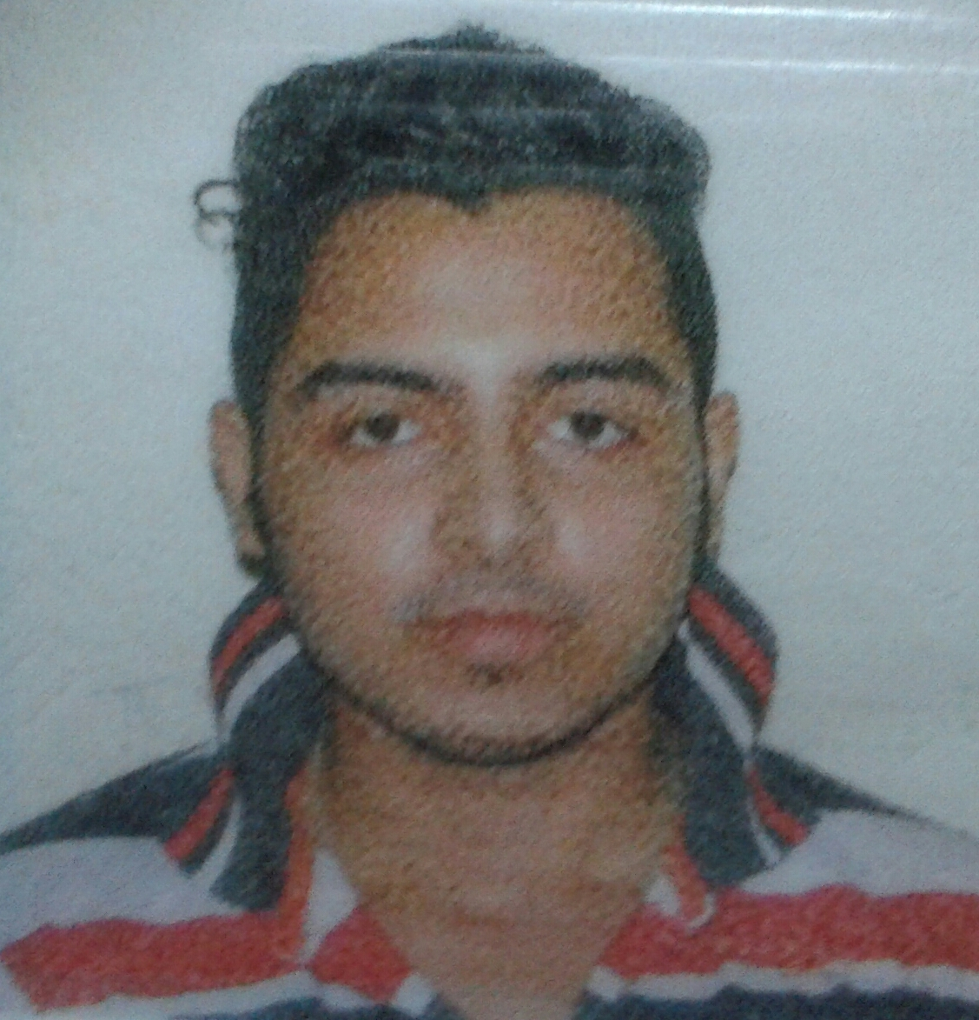

- ACADEMIC QUALIFICATION :-

YEAR OF PASSING | EXAMINATION | INSTITUTE/COLLEGE  SCHOOL | BOARD | CLASS/PERCENTAGE
2011 | 10th Standard | Kendriya Vidyalaya Command Hospital | C.B.S.E | 1st/60.00
2013 | 12th Standard( Com.) | Kendriya Vidyalaya Garden Reach | C.B.S.E | 1st/77.25
2016 | Graduate[ B.com(H)] | Heramba Chandra College | University of Calcutta | 2nd/44.00
2018 | Post Graduate(M.com) | University of Calcutta | University of Calcutta | 2nd/44.00
JUNE 2020 | MBA(Finance) | Calcutta Institute of Engineering and management | West Bengal University Of Technology | Pursuing/68.00

- ADDITIONAL DETAILS:-

Computer certificate course in Financial Accounting System from MUNSHI PREMCHAND YOUTH COMPUTER TRAINING CENTRE under DEPARTMENT OF YOUTH SERVICES, GOVERNMENT OF WEST BENGAL with A+ grade for the period ( i,e April 2013 to September 2013).

(C) INTERNSHIP:-

1. Trainee at DAMODAR VALLEY CORPORATION for the period (i,e 5th July 2019 to 23rd August
2019).

(D) PROJECTS:-

1. Comparative risk profile of TATA STEEL and HINDUSTAN UNILEVER LTD.
2. Working capital management in DAMODAR VALLEY CORPORATION.

(E) SKILLS :-

Accounting, Taxation, MS-Word, MS-PowerPoint, Tally, English Proficiency(Written and Spoken), Hindi Proficiency( Written and Spoken), Bengali Proficiency( Spoken).

(F) EXPERIENCE :-

Fresher

(G) HOBBIES AND INTEREST :-

Reading story books, playing football, watching cricket and as of interested in creating wealth.

(H)PERSONAL DETAILS:-

i) FATHER'S NAME : RAMESH SHAH
ii) ADDRESS : 4/2/H/3, Bhukailash Road, Kolkata - 700 023
iii) GENDER : Male
iv) DATE OF BIRTH : 17th July 1995
v) NATIONALITY : Indian
vi) MARTIAL STATUS : Unmarried

PLACE:- KOLKATA ---------------------------------------
DATE: - SIGNATURE

