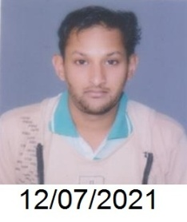

**Name :** SOUMIK GANGULY

**Address for Correspondence :**  **21 NORTH STATION ROAD MOTI-KUNJA KOL-700109**

P.O-AGARPARA

**Phone** : **91 8017350672 , 8902008156, 9836263907**

**Email** :  **soumikganguly1995@gmail.com**

.

|  |
| --- |
| **ACADEMIC BACKGROUND** |

|  |  |  |
| --- | --- | --- |
| **Qualification** | **Year of Passing** | **Percentage** |
| **Graduate B.A GENEREL** | **2018** | **40.4** |
| **12th** | **2014** | **50.2** |
| **10th** | **2011** | **72.3** |

EXPERIENCE I DISTRIBUTED SOME LIFLETS UNDER MY TEACHER AND FOR SOME ORGANIZATION

|  |
| --- |
| **ACADEMIC / EXTRA CURRICULAR ACHIEVEMENTS** |

**I know basic ms excel idea**

**ITI =I know stick welding Gash cutting,Mig welding , Arc welding**

* At school, I used to participate in verious sports activities
* Won several certificate and awards for debates and sports ( cricket .) at school as well as inter-school level

|  |
| --- |
| **PERSONAL DETAILS** |

Date of Birth 08/08/1995

Father’s Name : DEB KUMAR GANGULY

Mother’s Name : SHARMILA GANGULY

Gender : Male

Nationality : Indian

Religion : Hinduism

Home Town : kolkata

Permanent Address : 21 NORTH STATION ROAD MOTI-KUNJA P.O-AGARPARA

Languages Knowledge English, Bengali & Hindi

Mobility : willing to relocate Anywhere in India

I declare that the details above are correct and true to the best of my knowledge.

**I have Four wheeler and Two wheeler driving Liscence**

DATE SIGNATURE ( SOUMIK GANGULY)