Curriculum Vitae

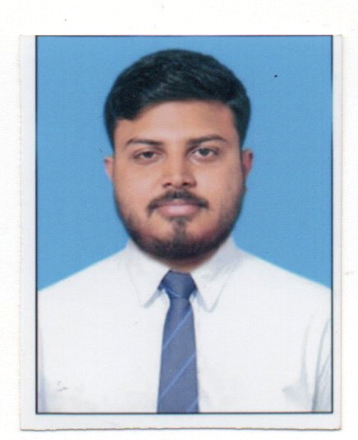

SUDIPTA DEY

Address:- Taherpur, Block-C

Road No. 16, plot -1965

P.O- Taherpur, P.S- Taherpur

Dist- Nadia, Pin-741159

West Bengal,India

Contact Number:- +91 9735925231

Email id:- [sudiptadeyHYPERLINK "mailto:sudiptadey610@gmail.com"0013HYPERLINK "mailto:sudiptadey610@gmail.com"@gmail.com](mailto:sudiptadey610@gmail.com)

**OBJECTIVES :**

Seeking a position with a dynamic organization where I can learn as well as contribute to the growth of the orgnization with my skill. I am fast and effective. I want to be a part of your success by offering high motivation,responsibility,quality work and keeping deadlines.

**PERSONAL DETAILS :**

Name:- Sudipta Dey.

Father’s Name:- Late Sashajit Dey.

Date of birth:- 07/11/1992.

Sex:- Male

Nationality: Indian.

Religion: Hinduism.

Maritial status: Unmarried

**EDUCATIONAL QUALIFICATION :**

|  |  |  |  |
| --- | --- | --- | --- |
| **NAME OF THE EXAMINATION** | **YEAR OF PASSING** | **BOARD/COUNCIL** | **MARKS[%]** |
| Madhyamik | 2009 | W.B.B.S.E | 75.75 |
| Higher Secondary | 2011 | W.B.C.H.S.E | 77 |
| Geaduation | 2014 | University Of Calcutta | 62.44 |

**COMPUTER SKILLS :**

Diploma in Information technology.

No difficulty in work with MS-EXCEL, MS-WORD, WINDOWS-XP, WINDOWS-7, MS- POWERPOINT.

**LANGUAGE PROFICIENCY :**  Fluent in English, Bengali and Hindi.

**INTERESTS :**  Quiz, Sports, Seminar, Music and Movie.

* + - * + .